Prayers to Avert War & A Gentle Correction
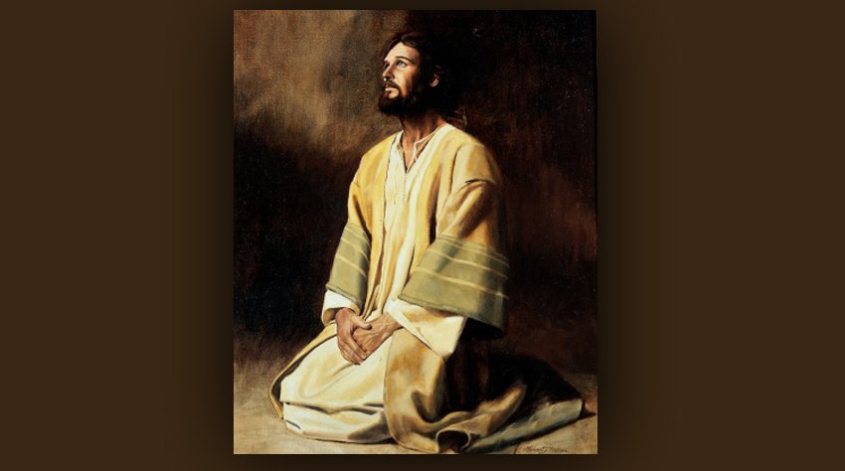
July 13, 2014

The Lord is with us Heartdwellers. He cares so very much for us.

This is just a short message, I know, but I wanted to bring to your attention the critical situation with Russia and NATO right now, and I felt that I had to get this message out, so that we could all pray. If any of you have been experiencing much more suffering lately, much more pain, many more crosses and problems, I can tell you that we, too, are in this place.

These last few days have been extremely hard, but as the Lord says in this dialogue, “This has been a rough day. But we're trying to avert a war you know.” And that is exactly what is going on. And today is a decisive meeting with the heads of state and NATO concerning Russia. Putin has been really actively trying to get America’s attention that we are headed for nuclear war, but of course the government controlled media is ignoring his attempts to get to us.

So, I am asking you all to pray for the world situation. Russia is poised for a war with NATO and the US and is expecting Obama to attack first. As we all know, his term of office has been about destroying America and now he is gunning for Russia to destroy our cities with nuclear war. Pray, dear ones, the situation is desperately drawing close to nuclear exchanges. And do not grow impatient in suffering. Jesus is gathering as many offerings as we are willing to give Him.

And I, for one, have had some struggles lately with showing restraint. And I have to say, though the issues were small, nothing is small when it comes to pleasing God.

"Make do with one, two are not necessary."

"More is less."

I was feeling badly because I knew I had blown it. And lately it seems like everyday is another struggle not to cook something sweet (failed there) and not to have more than you need. (Been giving lots of things away.)

And of course the demons love to shoot me full of arrows of condemnation and hopelessness. The Lord, though, was very tender in prayer and began immediately to comfort and admonish me.

He began, "Dear one, I am not here to condemn but to love. Yet as My Bride, you must give a generous example of self-control and have only those things that are really necessary to you and the ministry. Even then, I prefer you to be on the poor side."

Yes, Lord, I know.

"Put your head here, Clare, over My heart. You are being buffeted. You need to stand up to this and overcome it. There is really no more to say. Be a good and generous example of frugality, even in food.”

He continued, "This has been a rough day. We are trying to avert a war, you know."

Yes, Lord, I know.

"Prayer is working, but it’s not looking good. However, don’t stop praying. There are many more forces and dynamics in this mix than what is apparent - yet I don’t want you going into it and studying it. This would be a waste of your precious time."

OK, Lord. I understand.

"'It is good to be ignorant of many things for the Love of God', someone once said. A mind that is cluttered with the doings of the world is an unsettling place to be. I like a peaceful, simple mind best. You know, I must dwell there, too."

I know, Lord.

"Well, we are not giving up on you, Clare. Though your sins are many, your love is much too. And in the end, your love for Me will win over. So, stand tall in the saddle and don’t let those 'cattle' (that is, your flesh) break out of formation like unruly steers. You know when you please Me and when you are walking the edge. Acknowledging that is a sign that you want to cooperate with Me - it’s when you pretend it doesn’t matter that you fall. It does matter. It matters very much and if it makes you feel better, I am so very pleased when you really exercise self-control in the little things.

"Understand that success with the little things insures success with the bigger ones. It’s that holy staircase again: success builds upon success, failure weakens and paves the way for more failure. I love to see you take those steps upwards, and I am there at your right hand cheering you on."

And in that moment, I had a vision of the Lord. We were on a staircase to Heaven. I was wearing my wedding dress and we were ascending the staircase. He was on my right and was helping me, holding my hand and giving me strength with each step in self-denial. I almost felt like a little toddler holding Daddy’s hand. It was very sweet!

Well anyway, that's the long and short of it for today. Please, keep Russia, NATO and the US in your prayers. Understand that if things seem harder, it's for a very, very good reason.

The Lord bless you all.

